**NAME : LAKSHITHA RAJ VASANADU**

**ID : 00001115006**

**Class : 20406 (Morning Session)**

**COEN 278**

**WEB PROGRAMMIN II**

**ASSIGNMENT 3**

**1) To run the app on localhost:**

***ruby main.rb***

**2) The app has been deployed on heroku server and can be found at:**

[***https://lakshithastudentapp.herokuapp.com/***](https://lakshithastudentapp.herokuapp.com/)

**Home Screen**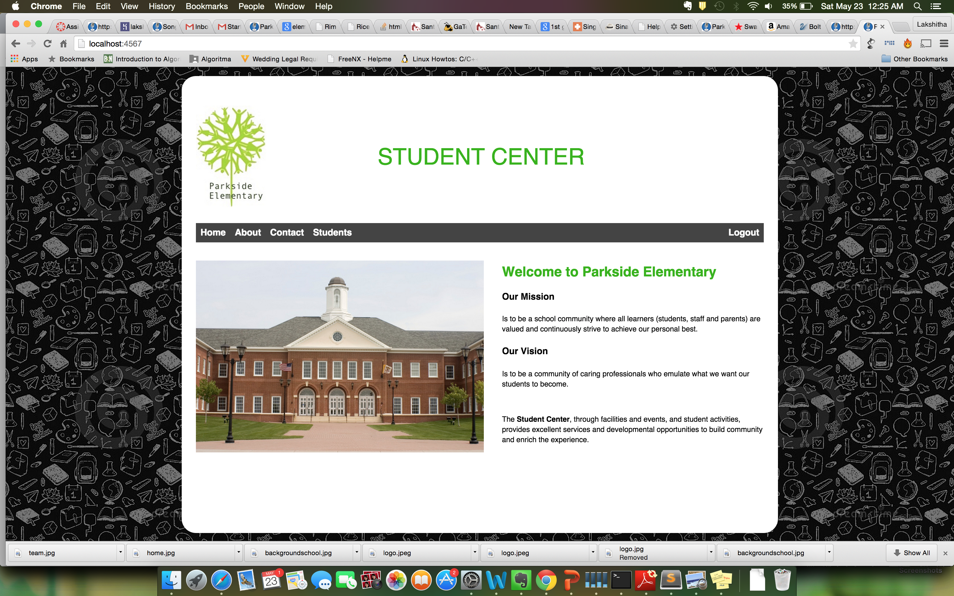

**About Screen**

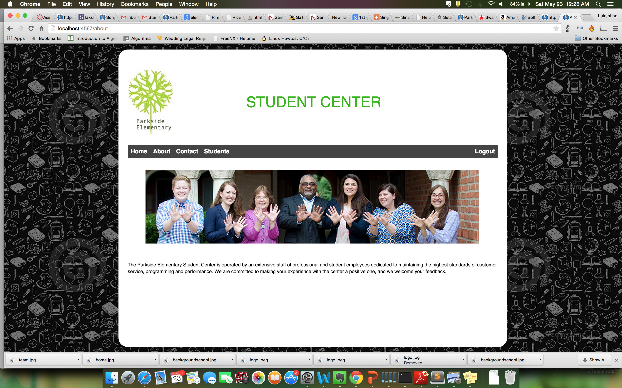

**Contact Screen**

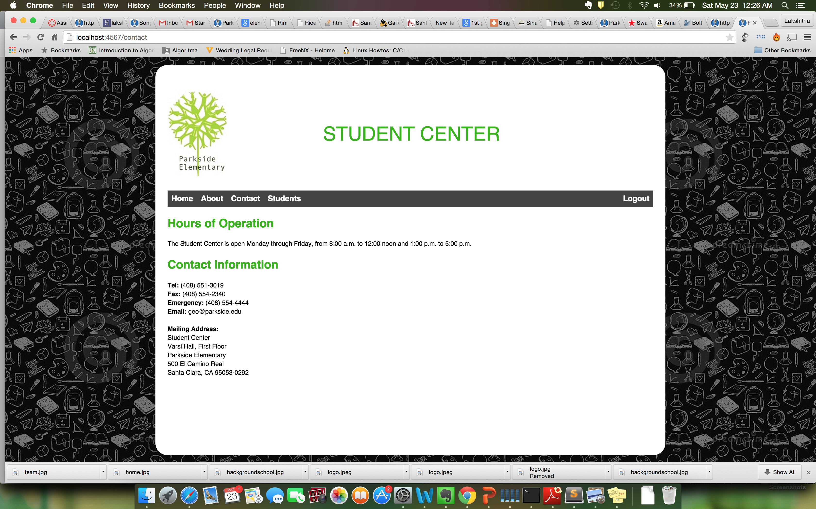

**Student Page (When not logged in)**

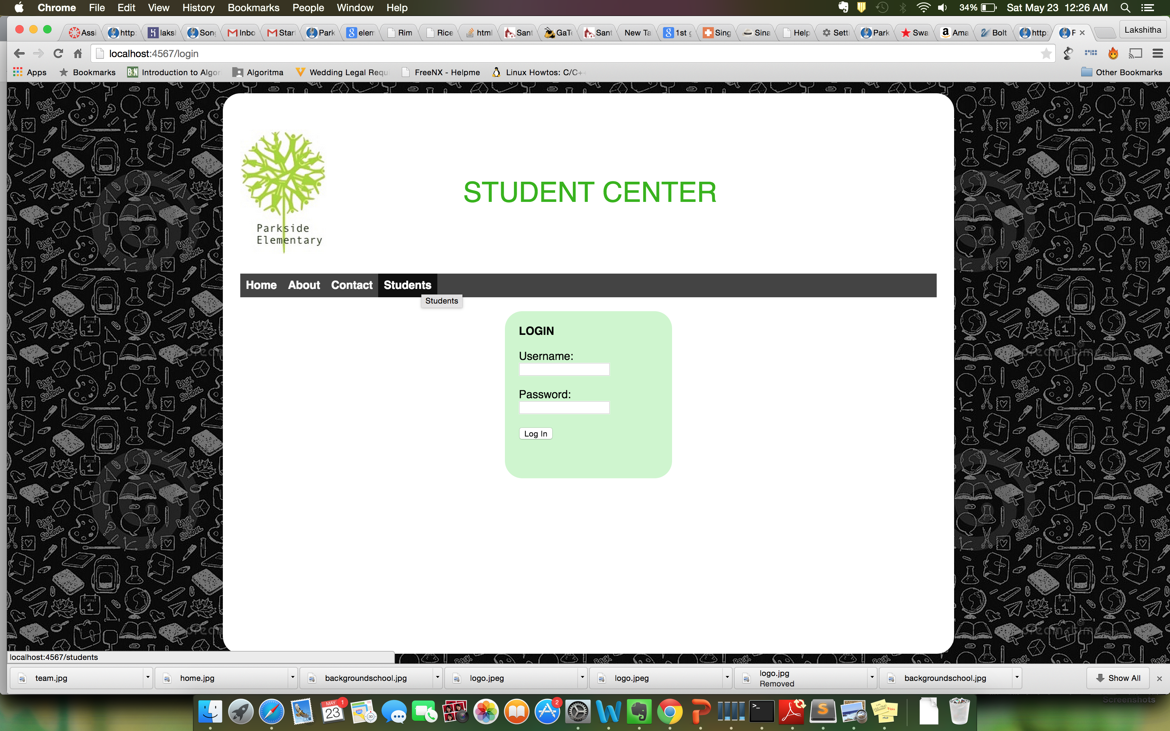

**Student Page (When logged in) – List students. Also, logout option is provided.**

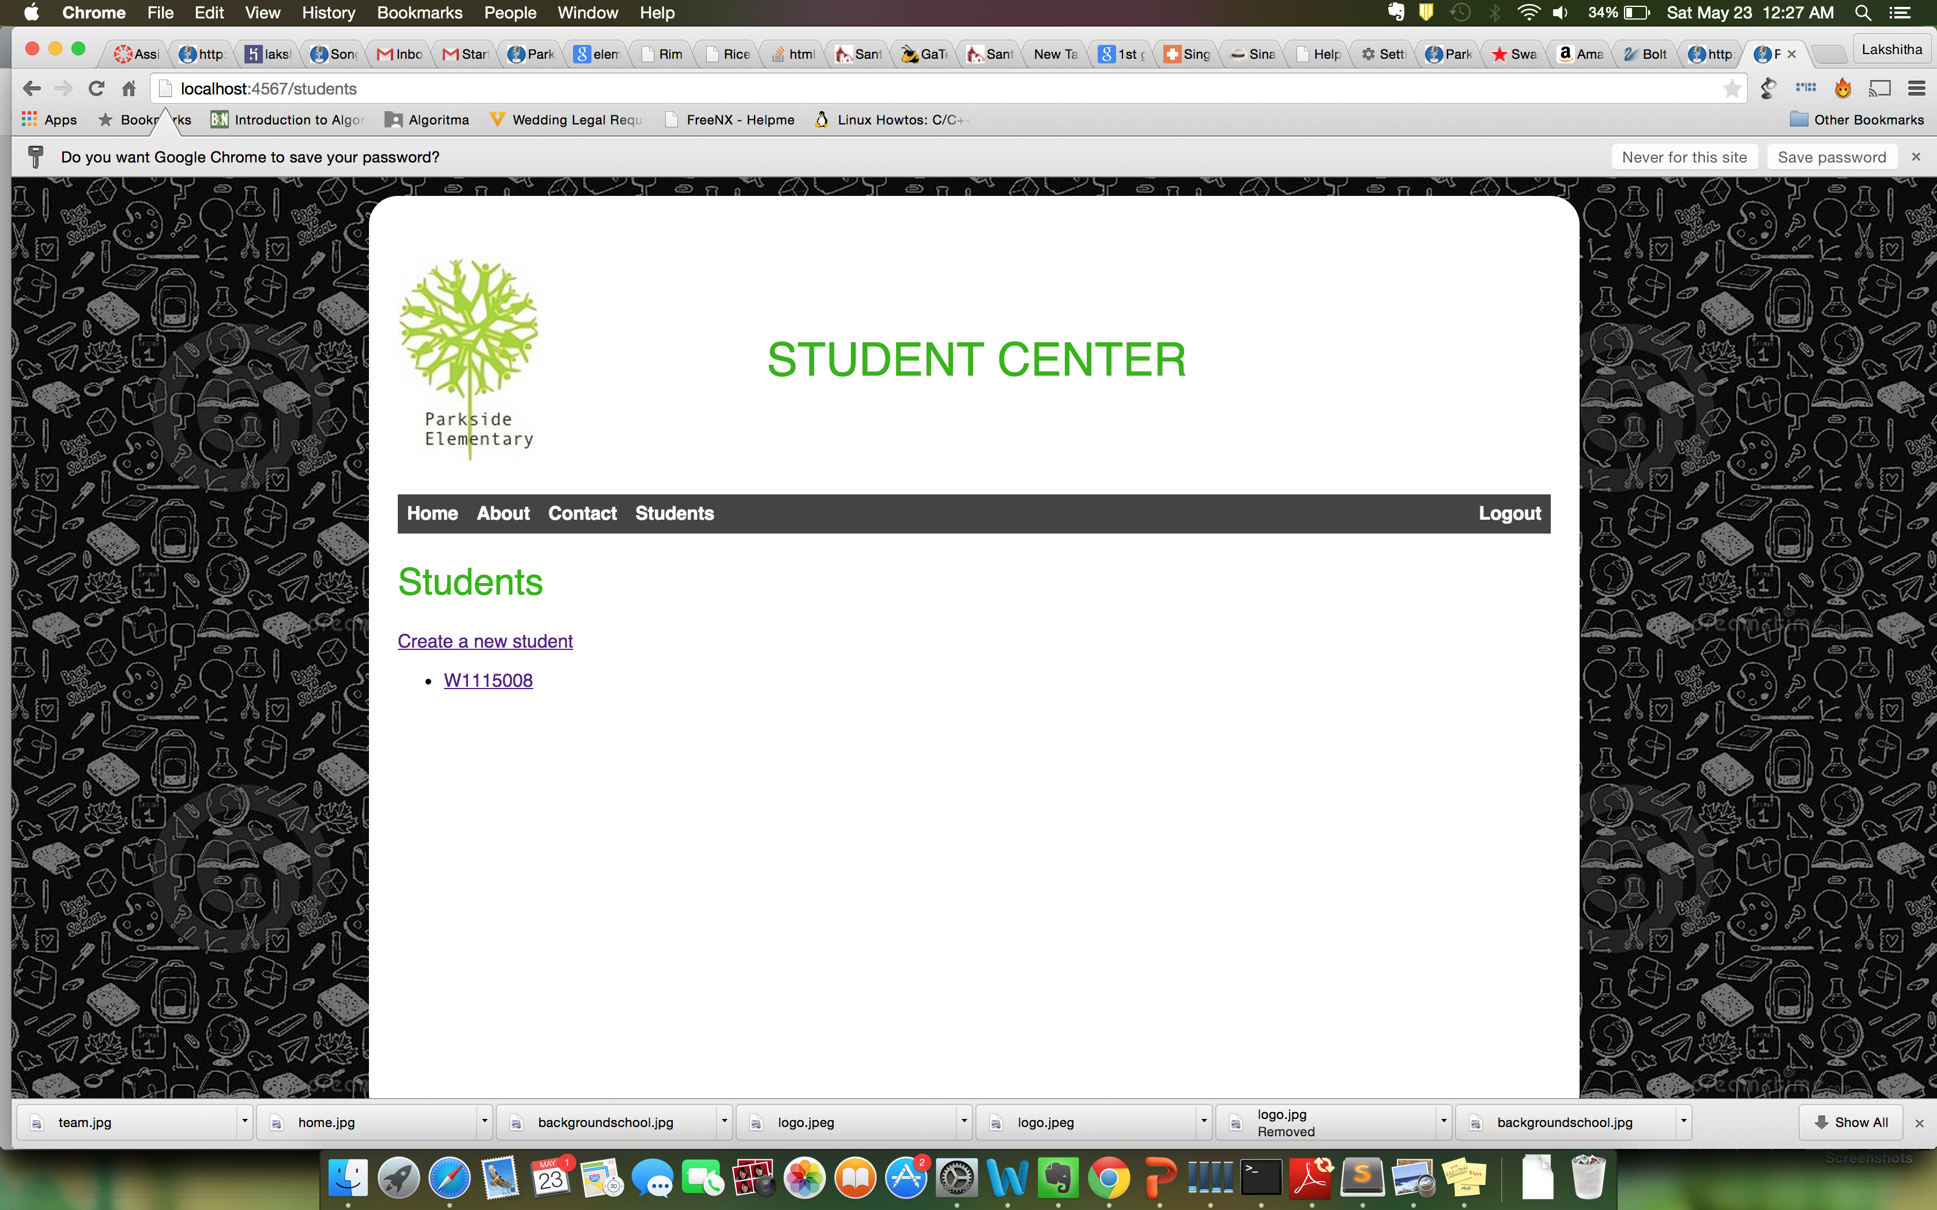

**Adding a new student:**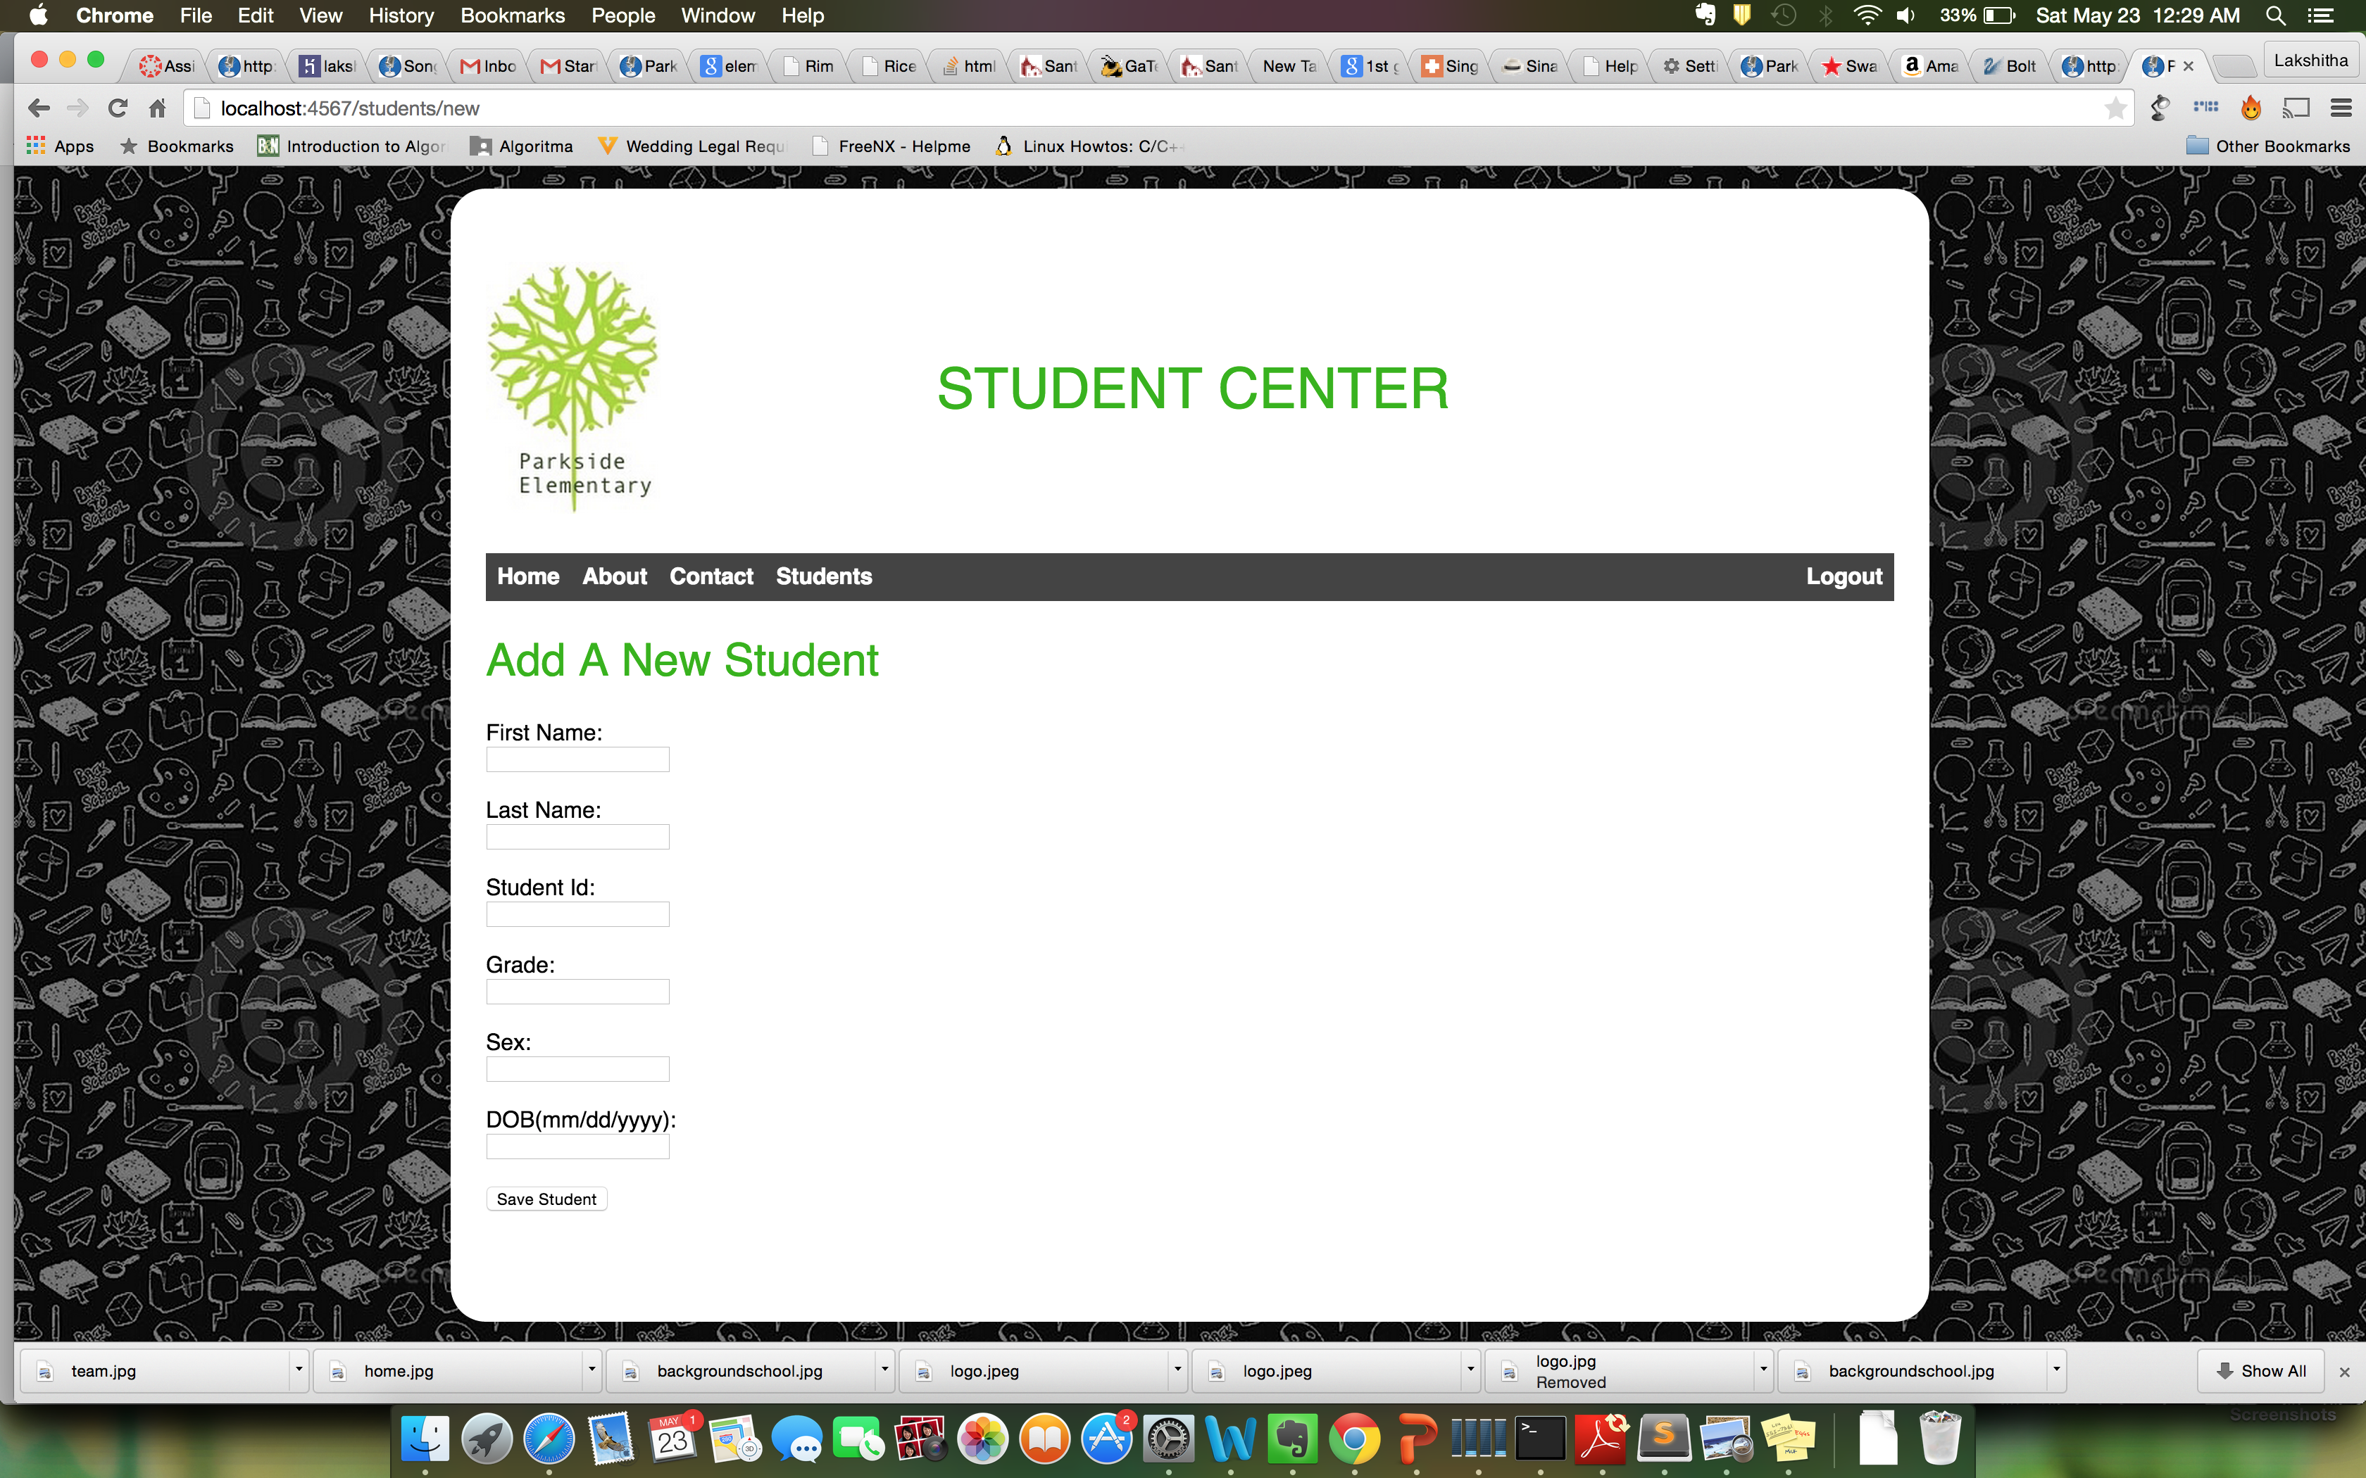

**Edit option:**

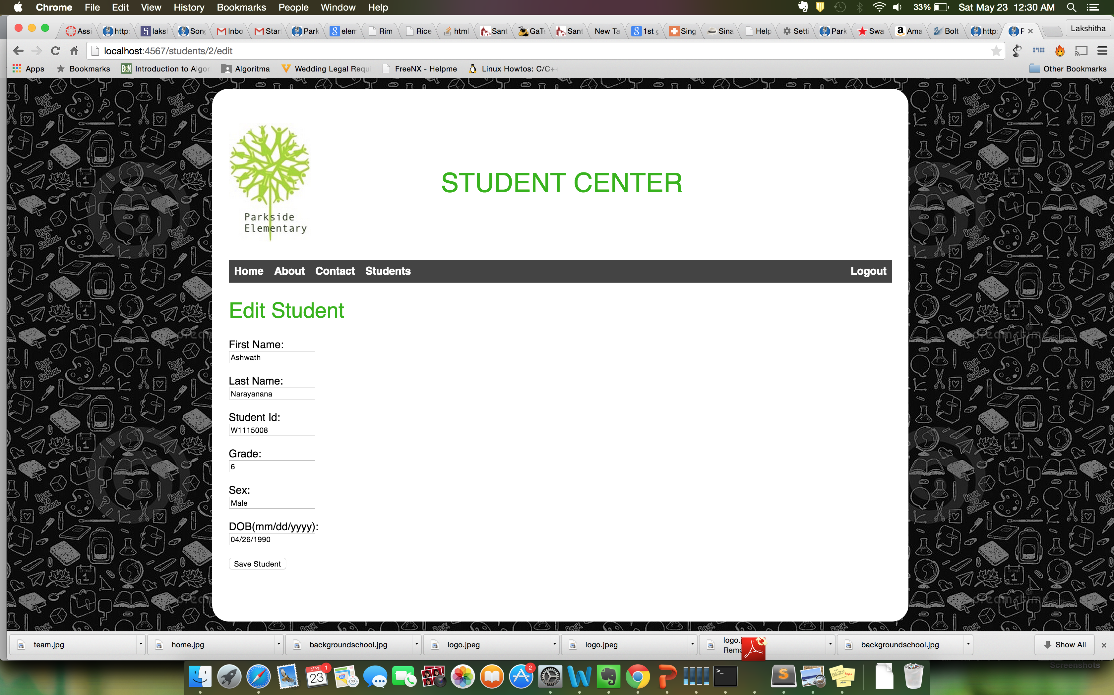

**Detailed view of student along with delete option:**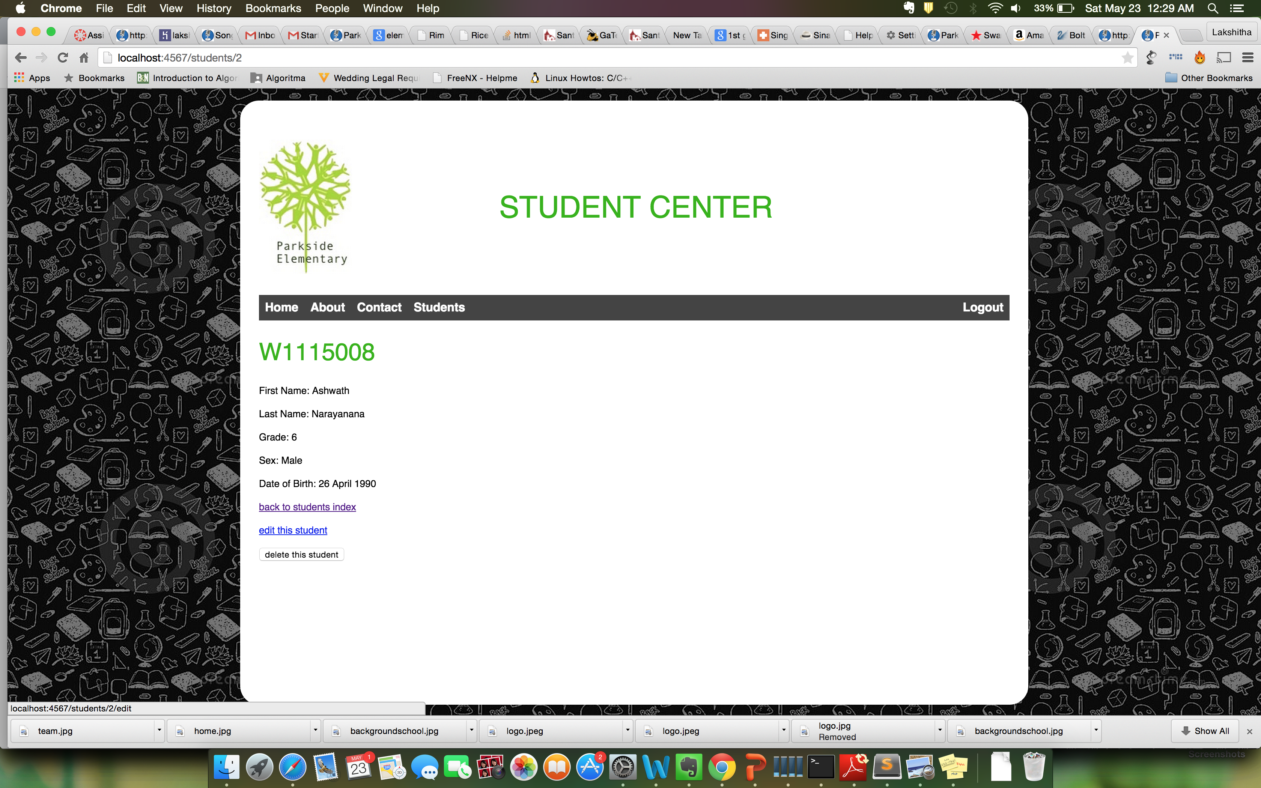

**404 page:**

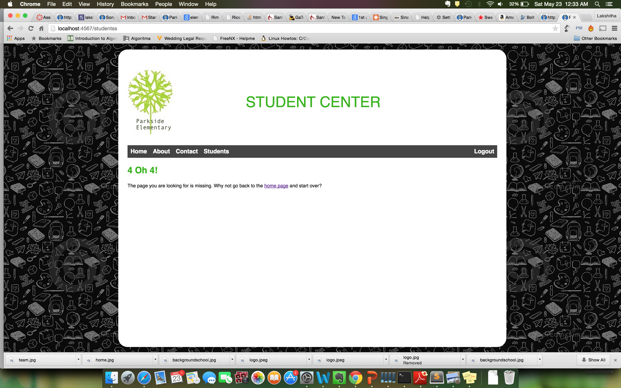

**Unauthorized page check when trying to do CRUD without login.**

